

**Infineon Technologies**

**22 August 2016**

**Hartmann Robert (IFAG ATV PTS SDACE)**

**Rexroth Indradrive (Mch)**

**User's Manual**

Table of Contents

1 Tool Concept 2

2 Hardware Set-up 2

2.1 Ports X31/X32 2

# Tool Concept

# Hardware Set-up

## Ports X31/X32

Following interface connections for ports X31 and X32 are available.

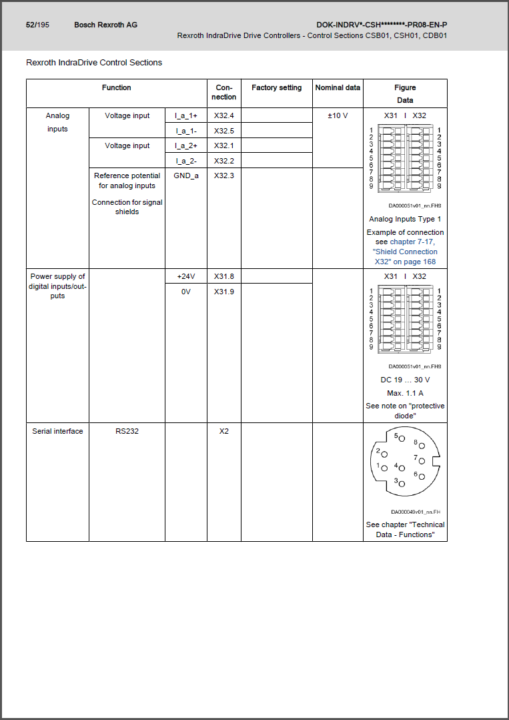

With regards to the row X… and its index number, the following mapping is defined by design:

|  |  |  |  |  |
| --- | --- | --- | --- | --- |
| **Index** | **Port X31** | | **Port X32** | |
| **1** | DO | Rel1a – Status word / P-0-0115, Bit 0 | AI | AI2+ (fixed) |
| **2** | DO | Rel1b – Status word / P-0-0115, Bit 0 | AI | AI2- (fixed) |
| **3** | DI | E-Stop / P-0-0223, Bit 0 | A | GND (fixed) |
| **4** | DI | Drive ON / P-04028 | AI | AI1+ (fixed) |
| **5** | DI | Travel Range Limit Switch / P-0-0222, Bit 0 | AI | AI1- (fixed) |
| **6** | DI | Travel Range Limit Switch / P-0-0222, Bit 1 | DO | Cam Ticks / %QB0 / P-0-1410, Bit 1  Tick for one single SPS cycle showing cam-trigger to next speed profile |
| **7** | DI | Sequence trigger / P-0-1390, Bit 0  0🡪1: Rising edge, which provides a valid trigger for cam-triggered speed profile.  1🡪0: Resetting sequence for restarting purposes | DO | Sequence Finished / %QB0 / P-0-1410, Bit 0 |
| **8** | A | +24V (fixed) | DO | Status word / P-0-0115, Bit 1 (Ready) |
| **9** | A | 0V (fixed) | DO | Status word / P-0-0115, Bit 13 (Drive error) |

# Software Set-up

## PLC I/O

|  |  |  |  |  |
| --- | --- | --- | --- | --- |
| **Dir.** | **Parameter** | **Type** | **Name** | **Usage** |
| Input | P-0-1370 | 4 Byte | PLC Global Register G0 | Number of bases for cam-triggered Speed profile. |
| Input | P-0-1389 | 1024 x 4 Byte | PLC Global Register GL0 | List of time values to be used as delay between each cam-trigger.  Unit: 10ms (Example: “200” 🡪 2000ms) |
| Input | P-0-1372 | 4 Byte | PLC Global Register G2 | Sequence trigger starting cam-triggered speed profile.   * Bit 0 = 0🡪1: Rising edge, which provides a valid trigger * Bit 0 = 1🡪0: Resetting sequence for restarting purposes |
| Input | P-0-1371 | 4 Byte | PLC Global Register G1 | Read trigger executing read process for PLC Global Register G0 (P-0-1370) and PLC Global Register GL0 (P-0-1389). |
| Output | P-0-1410 | 2 Byte | PLC Output WORD0 @ %QB0 | PLC Status word.   * Bit 0: Sequence finished * Bit 1: Cam Ticks (Tick for one single SPS cycle showing cam-trigger to next speed profile) * Bit 2: Drive has been stopped successfully * Bit 3: Drive has been started successfully * Bit 4: Error on applying new parameter values * Bit 5: New Sequence parameter applied successfully * Bit 6: Sequencer finished successfully * Bit 7: Sequencer execution interrupted or failed |

# Error Maintenance

|  |  |  |
| --- | --- | --- |
| Observation | Root cause | Fix/Workaround |
| * Motor |  |  |